Pre-Calculus 6-2 Circles and Ellipses

What do all points on a circle have in common? They are all the same distance, (the radius,) from a given point, (the center.) We can also make each point of a circle into a right triangle and use the Pythagorean Theorem to derive the formula of a circle. Consider a circle with a radius of 1 unit. Let P(x,y) represent any point on the circle. If we drop a vertical segment from point P, we create a right triangle with the x-axis. The length of the horizontal leg is x and the length of the vertical leg is y. So, using the Pythagorean Theorem for any point on the circle, x2 + y2 = 12. If we solve for y, we get another equation for a circle: y = .

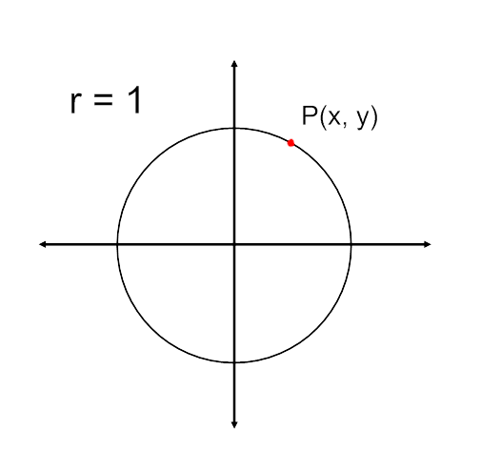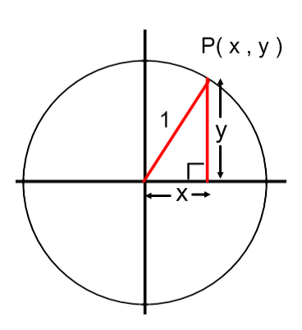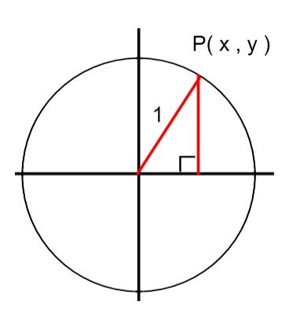

x2 + y2 = 12

***1. Desmos Circle Investigation***

a. How does the graph of  compare to ? Make a detailed sketch. Mark the center.

b. How does the graph of  compare to ? Make a detailed sketch. Mark the center.

c. How does the graph of  compare to ? Make a detailed sketch. Mark the center.

d. How does the graph of  compare to ? Make a detailed sketch. Mark the center.

e. How does the graph of  compare to ? Make a detailed sketch. Mark the center.

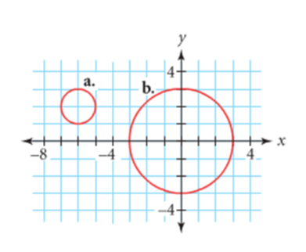***2. Applying What We’ve Seen***

Write an equation for each circle at right. Check your equations using desmos.com.

***a. _______________________***

***b. _______________________***

***3. Stretching Our Understanding***

a. How does the graph of  compare to ? Make a detailed sketch. Mark the center.

b. How does the graph of  compare to ? Make a detailed sketch. Mark the center.

c. How does the graph of  compare to ? Make a detailed sketch. Mark the center.

***4. Applying What We’ve Learned.***

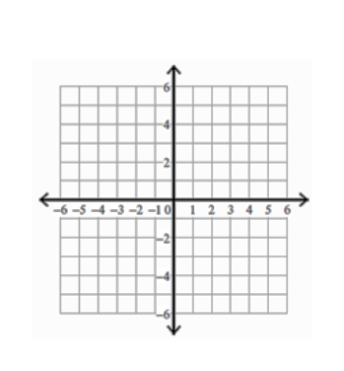**WITHOUT GRAPHING, make a prediction for the shape of each equation. Check your prediction using desmos.com. Make any necessary corrections to your sketch.**

a. Sketch  b. Sketch 

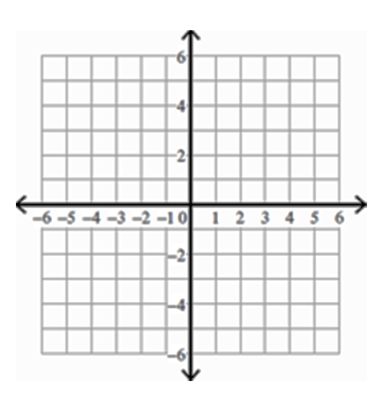c. Sketch  d. Sketch 

e. Sketch  f. Sketch 

***5. Generalizing What We’ve Learned***

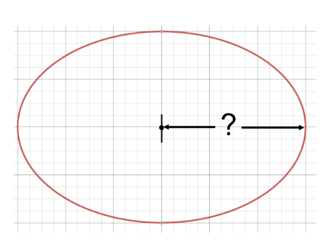Given a circle/ellipse in the form, , answer the following questions.

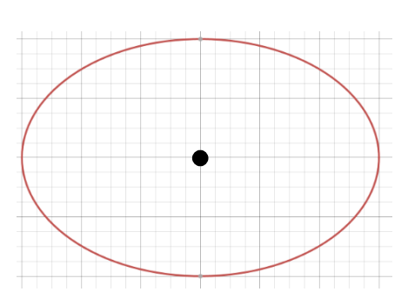What is center? __________ What is *horizontal distance* from the center

to either side?

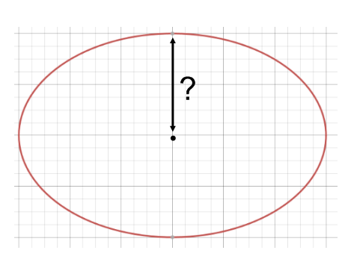

What is *vertical distance* from the center

to the top or bottom side?

***6. Practicing What We’ve Learned***

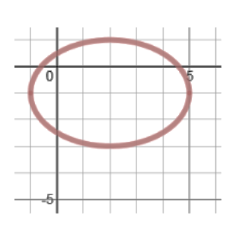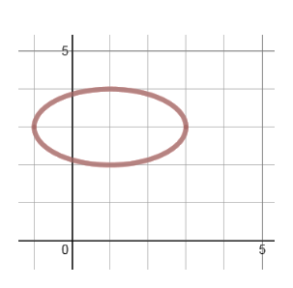6. Write equations of the following ellipses. Check your work using Desmos.com

a. b.

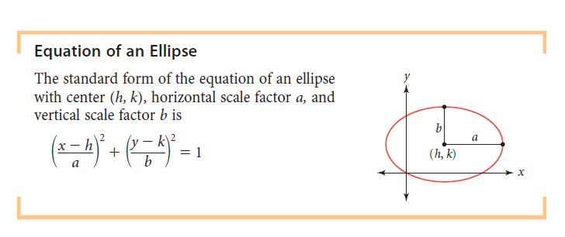You can think of an ellipse as a circle that’s been translated and dilated.

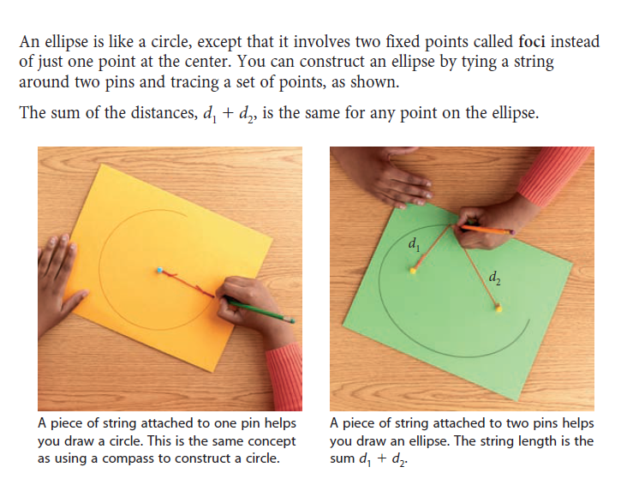

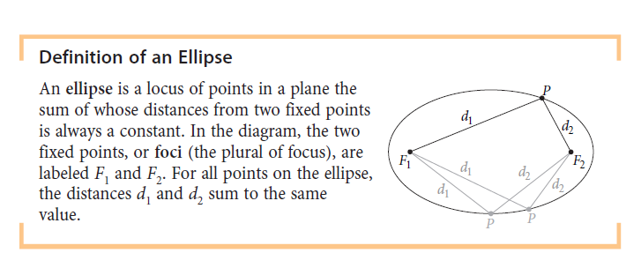

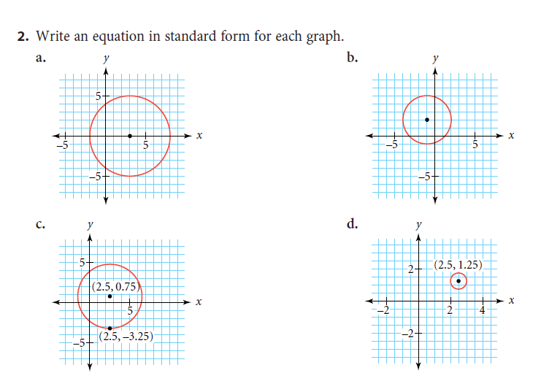Practice-

Check your work using Desmos.com

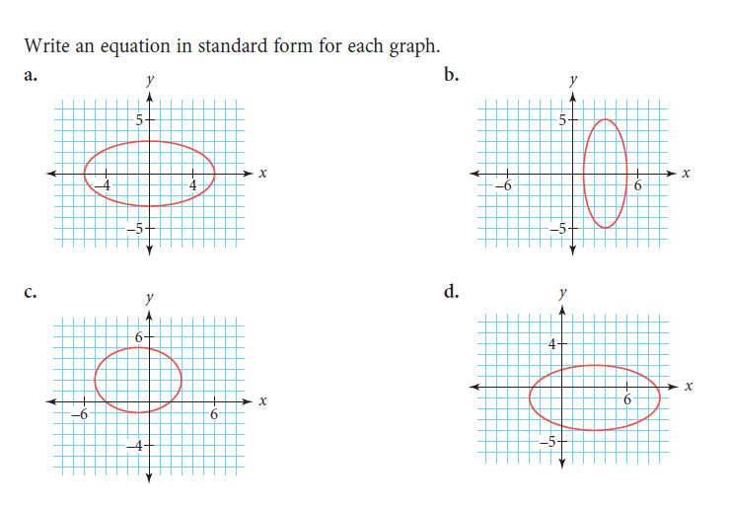

3.