**Pre Calculus- 7-3 Hyperbolas**

Conic Sections- So far, we have explored parabolas, circles, and ellipses. The only conic section left to explore are hyperbolas.

**Relating Hyperbolas and Ellipses**

**Part A-** Let’s use Desmos.com to explore hyperbolas. We can start with an idea we already a good grasp of.

**Step 1- Graph the following equation using desmos: .** Make a and b sliders. Play around with different values for a and b. We get an ellipse centered at (0,0) with a horizontal stretch factor of a and a vertical stretch factor of b.

**Step 2- Predict what the graph of  will look like. On the same graph, (***in ADDITION to the graph of the ellipse***,) enter the equation , using the same sliders as earlier.** Play around with different values of a and b. What do your ellipse and hyperbola have in common?

It is easy to see the effect the slider *a* has on the both the ellipse and hyperbola. What does the *b* slider have to do with anything? Let’s explore!

**Step 3- On the same graph, (***in ADDITION TO THE OTHER GRAPHS***,) as your ellipse and hyperbola, graph the following vertical and horizontal lines:**

x = a, x = -a, y = b, y = -b

We end up creating a rectangle using our horizontal and vertical stretch factors. (Remember that our center is (0,0). It won’t always be.) What do the vertices of this rectangle have to do with the hyperbola?

**Step 4- Write and graph the equations of the lines that pass though each of the diagonals of the rectangle.** [One line should include the points (-a, -b) and (a, b). The other line should include the points (-a, b) and (a, -b).]

What do these lines have to do with the hyperbola? (Check your answer with Mr. Herman or Mr. Carroll!)

**Step 5**

**How will the graph of the  relate to the graph of  ???**

Graph  along with all of the other equations from Part A. Play around with different slider values of a and b. What happens? Can you generalize the difference?

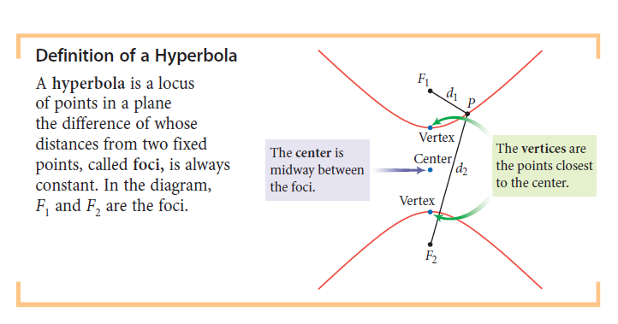Let’s get formal! Here are two different definitions of hyperbolas from different textbooks.

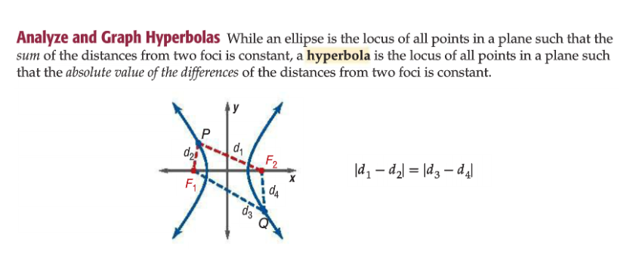

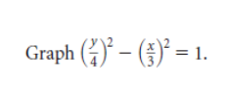**Let’s apply what we’ve seen so far!**

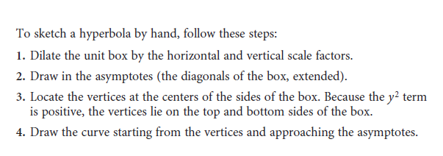**Let’s graph a hyperbola BY HAND!**

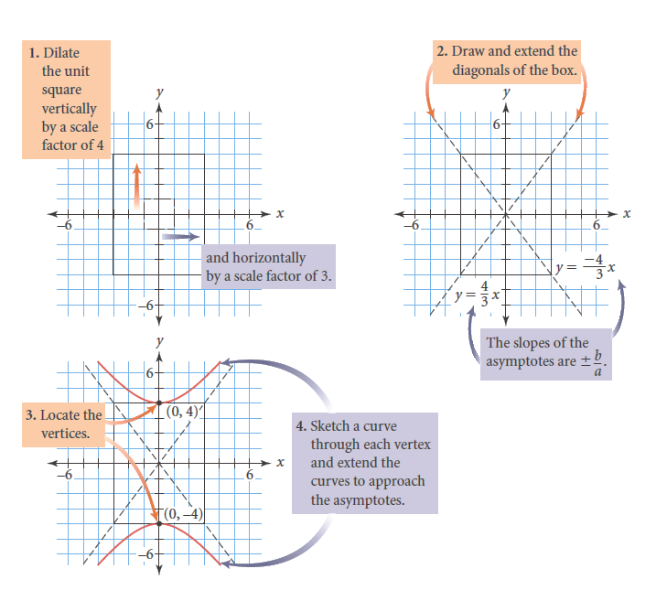

**Your Turn!**

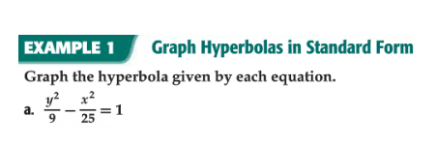

Questions to guide us

Does the hyperbola open up/down or left/right? How do we know?

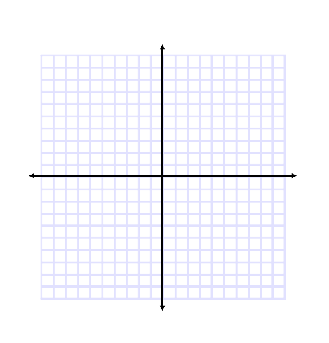What rectangle can we create using the horizontal and vertical scale factors to help us graph the hyperbola?

Where are the asymptotes? Where are the vertices?

Check your graph using desmos.com!

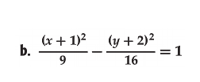

Graph the following hyperbola by hand. Check your work using desmos.

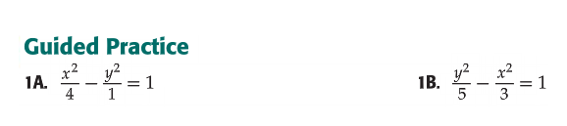Graph the following. Check your graphs in desmos.



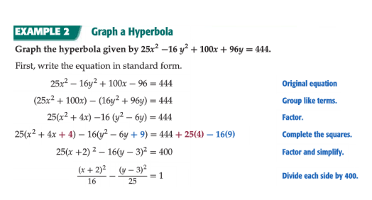What do we do if the hyperbola isn’t in standard form? We use completing the square to get it in the right form.

Sketch the graph at right. Check your graph using desmos.

(Hint: Where is the center going to be?)

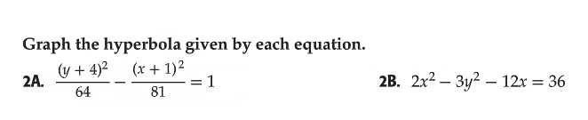Check your graphs in desmos.



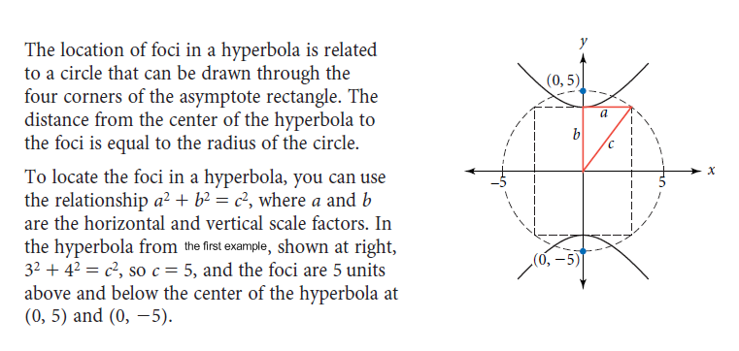**ONE MORE THING-** **LET’S GET FOCUSED!** The one piece of hyperbolas we have not looked into yet is their foci. For any hyperbola, we can draw a circle that will include both foci and ALL the vertices of the asymptote rectangle. This right triangle relationship allows us to calculate how far up/down or right/left the foci are from the center.

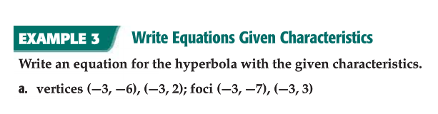

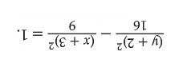

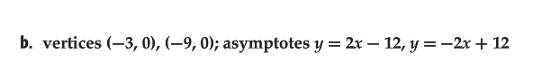

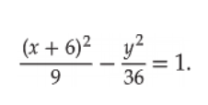

Some problems will refer to **the transverse and conjugate axis**. The transverse axis is the axis that connects the vertices and intersects the hyperbola. The conjugate axis is the axis that is perpendicular to the transverse axis and does not intersect the hyperbola.

Write the equation of a hyperbola with the given characteristics. 