**Using Desmos.com to Engage Students in Discovery Learning-** Sample Desmos Activities

John Herman [john.herman@lakemills.k12.wi.us](mailto:john.herman@lakemills.k12.wi.us) Lessons are available online at: http://www.lakemills.k12.wi.us/faculty/Jherman/DesmosLessons.cfm

Andrew Carroll [andrew.carroll@lakemills.k12.wi.us](mailto:andrew.carroll@lakemills.k12.wi.us)

*Middle/High School Algebra*

**Introduction to Graphing Lines**

On a new graph, click on the [+] to add an expression f(x). Type in “y = a + bx” It will ask you if you want to make a and b sliders. You do.

Play with different values for a and b. Questions for students: What effect does the value of a have on the graph? What effect does the value of b have on the graph? What happens if the value of a is positive? What happens if the value of a is negative? What happens if the value of b is positive? What happens if the value of b is negative? Where do you see the value of a on the graph? Where do you see the value of b on the graph? (They made need some help on this question depending on their understanding of slope.)

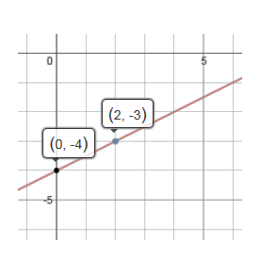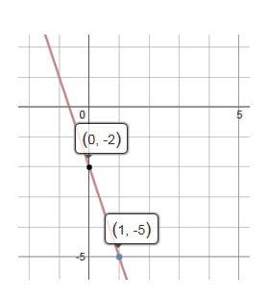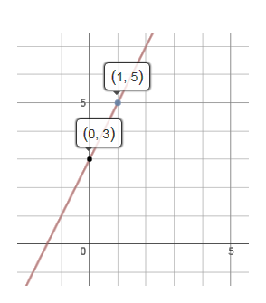Question for students: Can you find values for a and b that contain the points in the graphs below?

**Fitting Lines to Data**

Extending this idea down the road: Write a linear equation in the form y = a + bx that models the McDonald’s data below. Use this link to pull up the data: https://www.desmos.com/calculator/ye7p0unqem

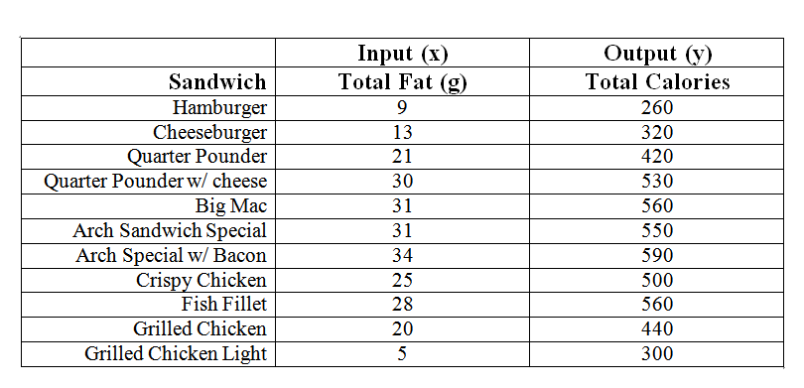Questions for students: How did you “find” your equation? Will everyone’s equation be the same? How could we do this purely algebraically?

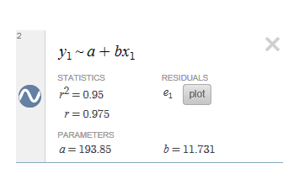

Typing the equation y1 ~ a +bx1 into Desmos will give the line of best fit and its statistics.

**Piecewise Functions**

Desmos makes understanding and working with piecewise functions a breeze. To graph the piecewise function:

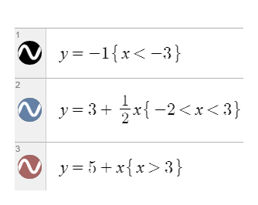 $f\left(x\right)=\left\{\begin{matrix}-1, when x<-3 \\ 3+\frac{1}{2x}, when-2<x<3 \\ 5+x, when x>3\end{matrix}\right.$, we can enter the following equations into Desmos:

**Transformations of Functions**

In the top left corner, there is a drop down menu. Click on new graph. Click on the [+] to add an expression f(x). Type in y = x2. This is our parent function. Click on the [+] to add another expression f(x). Type in “y - k = (x-h)2”. Make h and k sliders. Play with different values of h and k.

Questions for students: What is the effect of h and k on the graph? How will the graph of y – 3 =(x + 4) 2 compare to the parent function? How will the graph of y + 5 = (x – 4) 2 compare to the parent function?

Graph the two functions y = |x| and y – k = |x-h|. (You can hide your previous functions by clicking on the circle to the left of them.) Can you predict the effect of h and k on this new function?

Want to explore transformations of y = $\sqrt{x}$? Type in $\frac{ y-k}{b}$ = $\sqrt{\frac{x-h}{a}}$.

Want to play with the transformations of circles/ellipses? Graph: , in Desmos.

*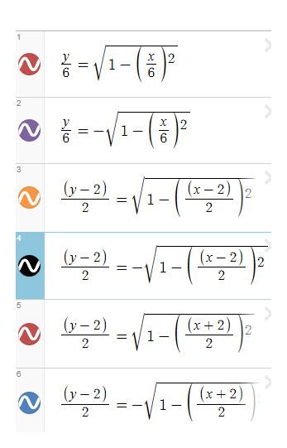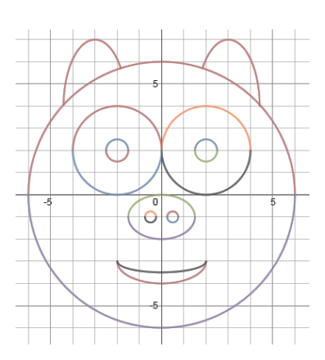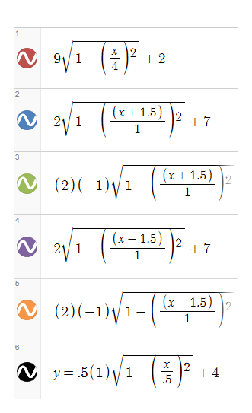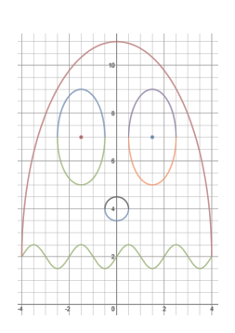Samples of student work after a transformations unit*:

**Inverses**

Desmos can graph functions that your graphing calculator cannot. You are able to graph x = 3, as well as x = 10y, and even x = sin y. What does the inverse of y = (x+3)2 + 4 look like? Just graph x = (y+3)2 + 4.

*Pre-Calculus and Algebra 2*

**Parametric Functions**

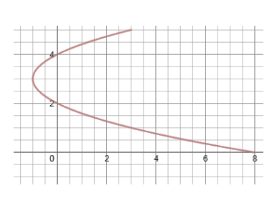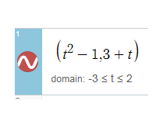Desmos can even graph parametric functions. You enter your parametric equations like you are entering an ordered pair. To graph the parametric x = t2 –1, and y = 3 + t, enter the function: (t^2 – 1, 3+t) and it will allow you to set the values of t you would like to view.

**Polar Equations**

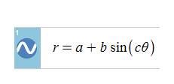If you click on the wrench in the top right corner of Desmos, you can change the grid to polar. Graph the following equation and experiment with the different sliders to play around with polar equations.

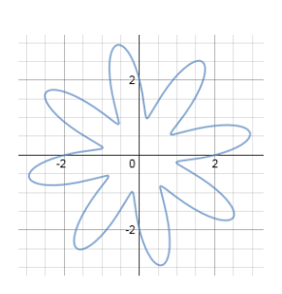

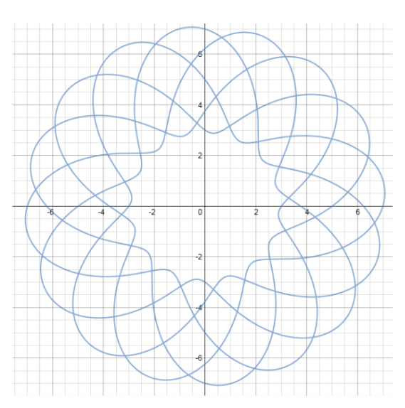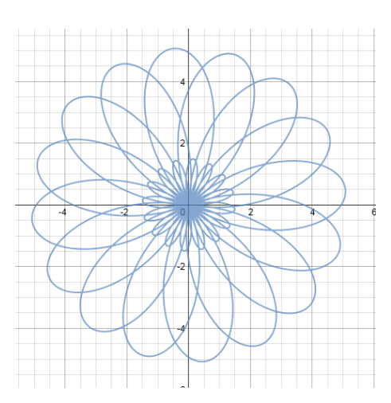

*Sample Activities- Algebra Lesson on Quadratics*

**Using Technology to Explore Quadratics**

1. In Desmos, graph the equation y=x^2+4x+3. What do we call the resulting shape? ____________________

What is the vertex? ( , ) What are the roots? _______and ____________

What is the equation of the line of symmetry? _______________ Graph it to test it out!

*Exploring Sliders and y =* a*x2*

2. Let’s explore what happens when we multiply our parent function x2 by some number a. Delete your other graphs, (use the X to the right of your equations to delete them.) Enter the equation y = *a*x^2. It will ask if you want to create a slider for *a*. Click on the blue box to make it one. Once you’ve created your slider, you can play around and see what happens to your graph for different values of a.

a. For what values of *a* does the graph open up?

b. For what values of *a* does the graph open down?

c. What happens to the parabola when the values for *a* get larger and larger?

d. For what value of a is the graph no longer a parabola?

*Using a Slider to Explore y = x 2 + c*

3. Delete all of your other equations. Graph the equation y = x2 AND the equation y = x2 + c. It will ask if you want to make *c* a slider. Click on the blue button to make it happen. Once you’ve created your slider, you can play around and see what happens to your graph for different values of c.

a. What happens to your parabola as the values for c get larger?

b. What happens to your parabola as the values for c get smaller?

c. How does the graph of y = x2 + 4 compare to the parent function y = x2?

d. How does the graph of y = x2 - 5 compare to the parent function y = x2?

*Using a Slider to Explore y = x 2 + bx*

4. Delete all of your other equations. Graph the equation y = x2 AND the equation y = x2 + bx. It will ask if you want to make *b* a slider. Click on the blue button to make it happen. Once you’ve created your slider, you can play around and see what happens to your graph for different values of b.

a. What happens to your parabola as the values for b get larger?

b. What happens to your parabola as the values for b get smaller?

*Exploring Factored Form y = (x-r1)(x-r2)*

5. So far, we’ve only explored quadratics in standard form, (y = ax2 + bx + c.) There are other forms we will use. Let’s explore factored form, y = (x-r1)(x-r2) for a bit.

a. Delete your other equations. Graph the equation y = (x-3)(x-5).

What are the roots? ________ and _______ What is the vertex? ( , )

What is the equation of the line of symmetry? ___________________ Test it by graphing!

b. Delete your other equations. Graph the equation y = (x+2)(x+1).

What are the roots? ________ and _______ What is the vertex? ( , )

What is the equation of the line of symmetry? ___________________ Test it by graphing!

c. Delete your other equations. Graph the equation y = (x+0)(x+8).

What are the roots? ________ and _______ What is the vertex? ( , )

What is the equation of the line of symmetry? ___________________ Test it by graphing!

d. Are you noticing a pattern yet? WITHOUT GRAPHING, guess what the roots will be for the equation y = (x - 4)(x - 6). Can you PREDICT what the line of symmetry will be without graphing?

Guess for the roots ________ and _________ Line of Symmetry ______________

Actual roots________ and _________ Actual Line of symmetry ______________

e. Try another! What will be the roots and line of symmetry for the equation y = (x + 2)(x – 6 )? Check your solutions.

Conclusion Time!

Let’s generalize what we’ve learned about factored form. Given an equation in factored form, how do we know what the roots will be? Explain! Discuss your results with a classmate.

Once we know the roots, how do we know what the equation of the line of symmetry will be WITHOUT graphing? Explain! Discuss your results with a classmate.

*Wrapping up the Investigation-*

Answer WITHOUT graphing.

1. Consider the equation y = -4x2 + 2x + 5. Will the graph open UP or DOWN? How do you know?

2. How does the graph of y = x2 + 3 compare to the graph of y = x2.

3. Which graph is wider, y = 2x2 or y = 8x2 ?

4. What are the roots and line of symmetry of the equation y = (x - 1) ( x - 5)?

Check ALL of your solutions by graphing using Desmos.

*Pre-Calculus Lesson on Modeling Using Trig. Functions*

**Modeling Using Sinusoidal Functions**

*Objective-Students will be able to perform transformations on a sinusoidal wave to model real world data.*

The real-life data at right gives the daily average maximum temperatures in Milwaukee from 1971-2000.

Use a chromebook to access this data on desmos.com by going to:

<https://www.desmos.com/calculator/nofrfmhp8w>

**Our goal is to fit a sinusoidal wave to this data to model the maximum temperature throughout the year.**

1. Spend a couple of minutes guessing and checking values of a, b, c, and d in the function y = asin(b(x+c))+d or y = acos(b(x+c))+d that fit this data.

What was your best guess? _________________________

**2. Mathematically Creating A Better Model**

a. How can we use the data to calculate the amplitude?

b. How can we use the data to calculate the vertical shift necessary?

c. What period makes sense for yearly weather data? What value of b will give us this period?

d. The last component we need to calculate is the phase shift. Graph your function using the values we found in 2a-2c. How can we calculate how far we would need to shift our wave for it to work?

*What equation did you come up with? How does it compare to other groups?*

e. Can you write BOTH a sine and cosine wave that models this data?

**3. Making Predictions Using our Model**

a. Use your model to predict the maximum temperature in Milwaukee on the 5th of January.

b. Predict what day of the year will have the coldest maximum temperature in Milwaukee.

c. Predict what day of the year will have the warmest maximum temperature in Milwaukee.

**4. A Better Model?**

a. How would we use our graphing calculator to create the “best” sine wave to fit our data? (You don’t have to actually do this, just explain how it can be done.)

*Pre-Calculus Lesson on Hyperbolas*

**Pre-Calculus- 7-3 Hyperbolas**

Conic Sections- So far, we have explored parabolas, circles, and ellipses. The only conic section left to explore are hyperbolas.

**Relating Hyperbolas and Ellipses**

**Part A-** Let’s use Desmos.com to explore hyperbolas. We can start with an idea we already a good grasp of.

**Step 1- Graph the following equation using desmos: .** Make a and b sliders. Play around with different values for a and b. We get an ellipse centered at (0,0) with a horizontal stretch factor of a and a vertical stretch factor of b.

**Step 2- Predict what the graph of  will look like. On the same graph, (***in ADDITION to the graph of the ellipse***,) enter the equation , using the same sliders as earlier.** Play around with different values of a and b. What do your ellipse and hyperbola have in common?

It is easy to see the effect the slider *a* has on the both the ellipse and hyperbola. What does the *b* slider have to do with anything? Let’s explore!

**Step 3- On the same graph, (***in ADDITION TO THE OTHER GRAPHS***,) as your ellipse and hyperbola, graph the following vertical and horizontal lines:**

x = a, x = -a, y = b, y = -b

We end up creating a rectangle using our horizontal and vertical stretch factors. (Remember that our center is (0,0). It won’t always be.) What do the vertices of this rectangle have to do with the hyperbola?

**Step 4- Write and graph the equations of the lines that pass though each of the diagonals of the rectangle.** [One line should include the points (-a, -b) and (a, b). The other line should include the points (-a, b) and (a, -b).]

What do these lines have to do with the hyperbola? (Check your answer with Mr. Herman or Mr. Carroll!)

**Step 5**

**How will the graph of the  relate to the graph of  ???**

Graph  along with all of the other equations from Part A. Play around with different slider values of a and b. What happens? Can you generalize the difference?